Manideep reddy.K

2403a54096

ASSIGNMENT:2.1

Task Description #1

* Use Google Gemini in Colab to write a Python function that reads a list of numbers and calculates the mean, minimum, and maximum values.

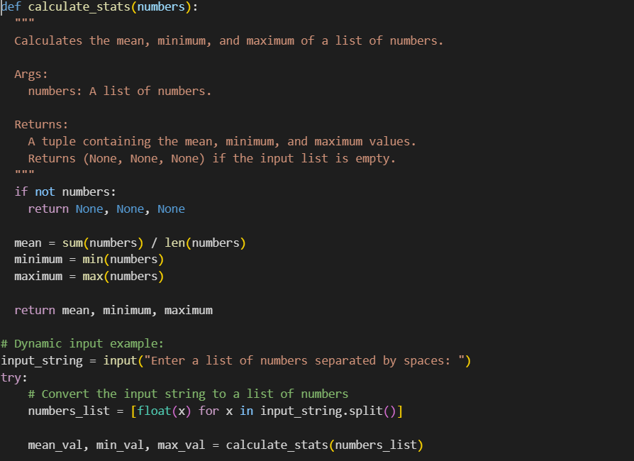

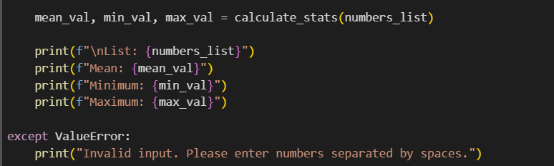

**Output:**

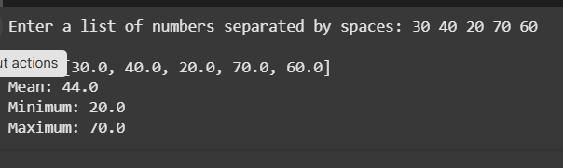

Task Description #2

* Compare Gemini and Copilot outputs for a Python function that checks whether a number is an Armstrong number. Document the steps, prompts, and outputs.

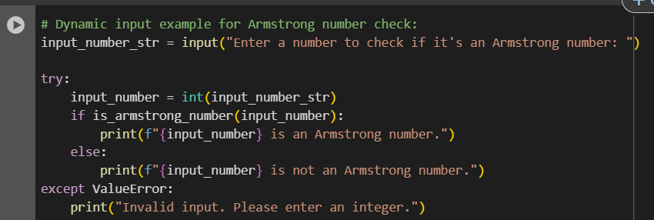

Output:

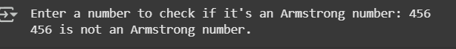

Side-by-side comparison table :

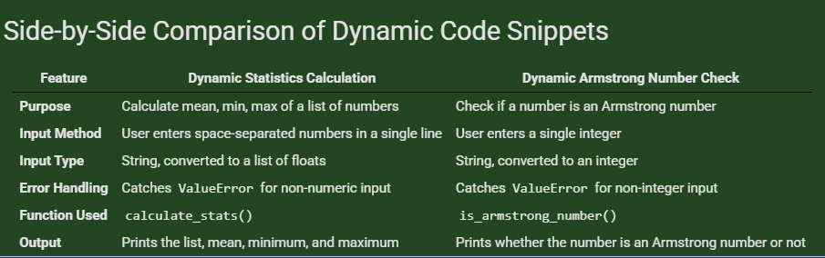

Task Description #3

* Ask Gemini to explain a Python function (e.g., is_prime(n) or is_palindrome(s)) line by line.

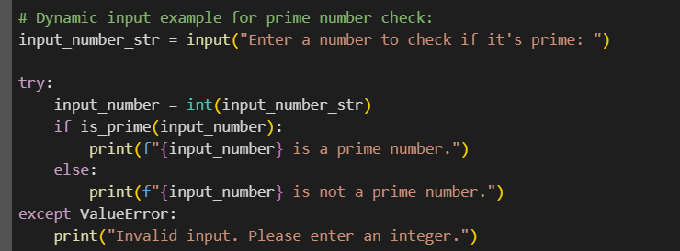

**Output:**

**Screenshot 2025-08-20 201243**

Task Description #4

* Install and configure Cursor AI. Use it to generate a Python function (e.g., sum of the first N natural numbers) and test its output.

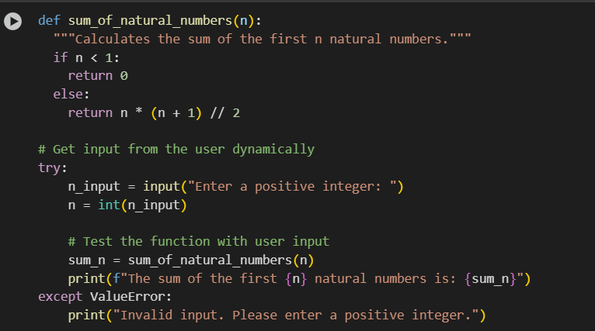

Output:



Task Description #5

Students need to write a Python program to calculate the sum of odd numbers and even numbers in a given tuple

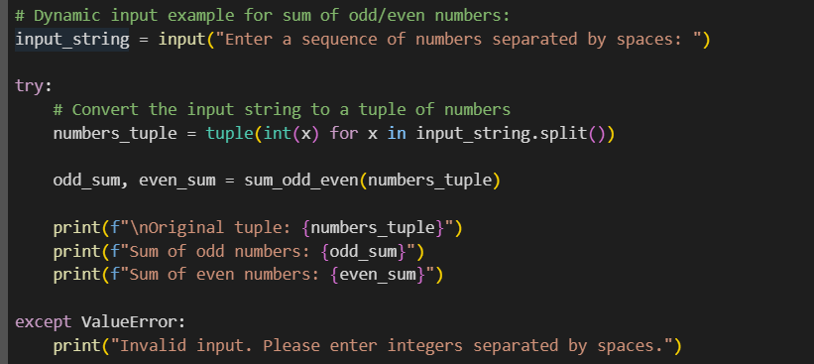

Output:

